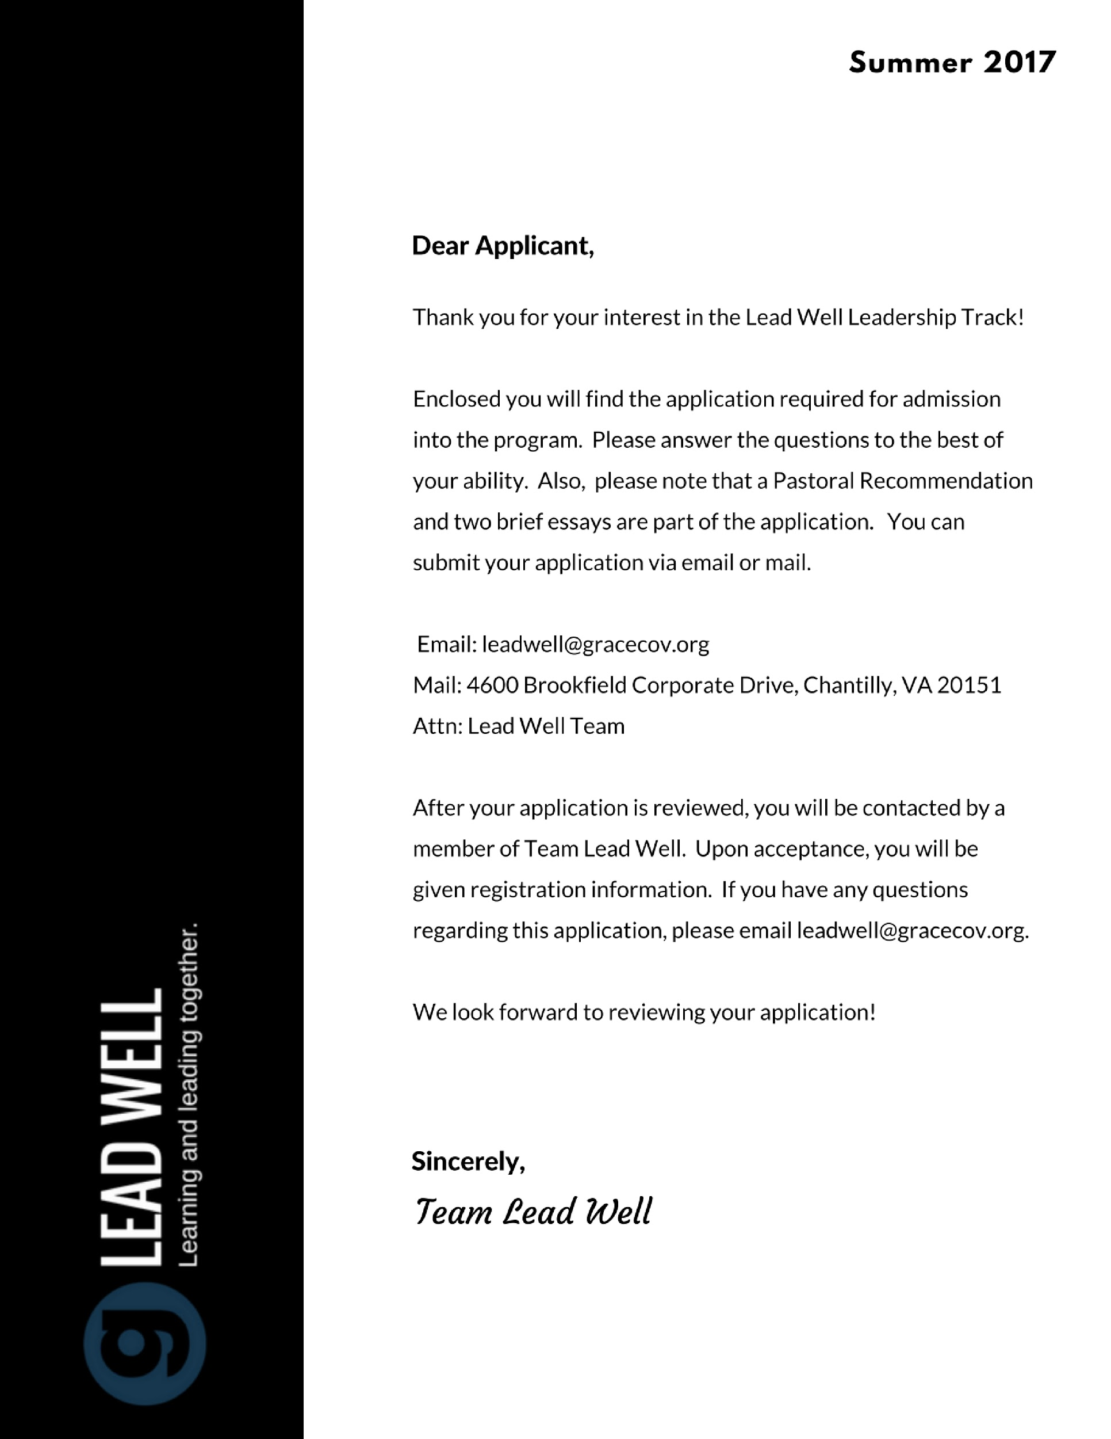GENERAL INFORMATION
Full Name __________________________________________________________________________
Address ____________________________________________________________________________
City ______________________________ State ______________________Zip ___________________
Phone ___________________________________ Email Address ______________________________
Gender _________________________ Age _____________________ Marital Status ______________
Are you a member of Grace Covenant Church? _____________________________________________
Will you be requesting Financial Aid? ___________________________________________________________________________________
Applicant Signature _________________________________________ Date _____________________
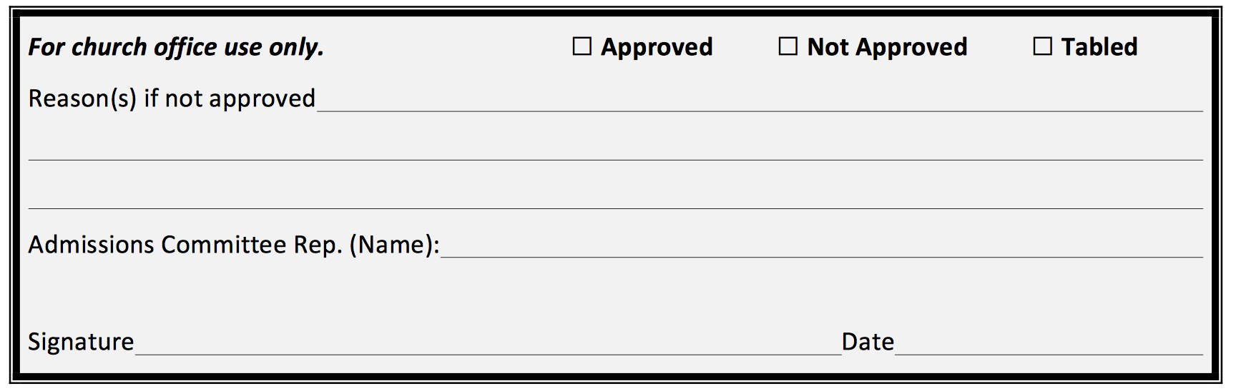

APPLICANT CHECKLIST
- Complete General Information and Personal Reflection sections.
- Ask your pastor to fill out a recommendation form and submit it.
- Essay 1: Personal Testimony: Describe how you came to faith and your current relationship with God in 100 - 500 words.
- Essay 2: Gospel Description: Describe the Gospel in 100- 500 words

PERSONAL REFLECTION
Have you been baptized in water?

Have you experienced the baptism of the the Holy Spirit?

Have you completed the Purple Book (Biblical Foundations)?

Describe your prayer life.

Describe your Bible reading routine.

Have you ever led someone…
- To repent & believe the Gospel?
- To be water baptized?
- To be filled with the Holy Spirit?
- Join a small group?
- Join a service team?

Have you ever led a small group?
Are you leading a small group(s) now?
List your greatest character strengths.

List your greatest character weaknesses.

List your primary spiritual gifts.

List any current ministry responsibilities.

Describe what you believe is your ministry calling. (full-time ministry, bivocational ministry, workplace ministry, etc)

List the key spiritual mentors who have helped shape your life, and how they impacted you.

Describe your most significant past or present ministry/spiritual leadership responsibility, and the corresponding results/fruit that came from it.

List any pertinent church ministry training programs or classes you’ve completed (i.e. Restoring the Foundations, School of Empowerment, college/university programs).

Are there any significant personal issues of which the program should be aware? (e.g., prior divorce(s), criminal record, addictions, mental health issues, etc.).Please describe.

How do the mission, vision, and values of Grace Covenant Church and Every Nation correspond to your own beliefs and worldview? (See their respective websites.) Please elaborate.

What do you hope to get out of this program?

ESSAYS
Please attach your Personal Testimony and Gospel Description essays.

PASTORAL RECOMMENDATION – TO BE COMPLETED BY A PASTOR

Pastor’s Name _______________________________________________________________________
Church Name ________________________________________________________________________
Applicant’s Name ____________________________________________________________________

Do you believe this person has a divine call to full-time church ministry or to high levels of bi-vocational Christian leadership in church ministry?

Do you recommend this person for admittance into the program? Why or why not?

Does the applicant have any character/spiritual issues of which we should be aware?

Pastor’s Signature _____________________________________________ Date _________________

